Final Report Template for Web Technology Course

**Project title: Digital Marketing-Case of final year project**

**Department of Computer and Software Engineering-SoICT, UR**

**Submitted by: 221012822 SHYIRAMBERE Emmanuel**

**Year 2, CSE**

**Academic year: 2021-2022**

Table of Contents

**1. Introduction** 2

**1.1.** **Project Summary** 2

**1.2 Problem statement** 2

**1.3 Objectives** 2

1.4 Project Rationale 2

**2. Methodologies and Methods** 2

**2.1** **Data collection methodology** 2

**2.2 Tools to be used** 2

**2.2.1 Hardware tools** 2

**2.2.2 Software tools** 3

**3. System Analysis and Design** 3

**3.1** **Requirement Specifications** 3

**3.1.1 Functional requirements** 3

**5.** **Conclusion** 3

# **1. Introduction**

## **Project Summary**

By the definition of the project title, Digital marketing is the form of advertising by the use of internet with help of electronic tools such as social medias, smart phone, computers, web browsers, and many more. This project is aimed to provide efficient marketing zone between the consumers and the producers, where the producer with their category and their prices provides the products. Now, the users (consumers) are able to purchase any products depends to their choices in the convenient manner.

## **1.2 Problem statement**

In real world, there is possibility of shortage of some products on the markets depending to the location areas, availability of promotion, prices from some producers, less investments on common products, etc. Those problems facilitates the reduction in demand, production process in the economy, standard of living among people, and consumers’ choice; which also leads to the less exports, lack of globalization, less connectivity among people, and at the end promote the reduction in the national income.

## **1.3 Objectives**

The project is aimed at the point of effective provision of differenciatable market structure where all products have no limits to be provided by the producers in order to increase the availability for consumers’ choices, products with convenient prices, huge exportation that increases the national GDP, communications, globalization that promote public relations.

## **Project Rationale**

There are many solutions and importants intended to proceed, because it is able to provide such as problem of people who take long distance to the market(those from foreign countries) should their demanded products be delivered to their location areas which also increase exports and globalization, effective resources allocation where producers will produces products related to the mostly demanded also depends on customers wishes from their comments, the increase in provision of high quality products enhanced by availability of competition which also facilitate reduction of shortage of products on markets.

# **2. Methodologies and Methods**

## **Data collection methodology**

Firstly, I am the one who faced with the problem of shortage of some products on many markets and other problems stated above. Then after, I observed that not only me who had such problems because many of people I tried to ask about it, those answered that they already had such problems. Therefore, I started to think about how to overcome them.

## **2.2 Tools to be used**

## **2.2.1 Hardware tools**

This project requires the owner to have a computer in order to use different software to design project , linked server used to store the users’ data and information and some disks drives (in addition with other secondary storages), and networking tools (such as router, swithes, and power supply).

### **2.2.2 Software tools**

Software such as notepad, PHP, MySQL, visual studio code, bootstrap and other editing software tools are needed in the development and implementation process.

# **3. System Analysis and Design**

## **Requirement Specifications**

### **3.1.1. Functional requirements**

This project is designed; to request the minimum steps to make any purchase, to be mobile responsive, to print product attributes, to have unique and recognizable design, to make social sharing, orders and checkout flow, availing payments methods and high performance with increased security.

### **3.1.2 Data Requirements**

The system information from each one who need access to the project in order to ensure security of our platforms. By the way, any stake holder (manufacturers or retailers) must create an account for the first time by providing their names, phone number, username he will be using at login page and so on; while registration, they must log in with their username and password used during signing up in order being able to start producing products.

* **ERD**

then

|  |
| --- |
| Sign-up |
| Names  Username  Country  Phone-No  Password |

|  |
| --- |
| Log-in |
| Username  Password |

|  |
| --- |
| Contact |
| Names  Phone-No  Comments |

produce

|  |
| --- |
| Producer |
| ProductName  price  Country  Product-type  user-type |

### **3.1.3 User Requirements**

Firstly. This system requires at least one admin who is responsible for administration management by organizing products and services for their owners in order to avoid inconvenience in terms of prices, product type, and the methods of payments. Secondly, it will need the stakeholders (manufacturers and retailers of products) who are responsible to produce their products on our platforms. At the end, the end users such as visitors and customers are to purchase or giving ideas and advices for how we can improve our quality of services.

### **Security Requirements**

This is designed with capability to record the users’ access and administrative privileges where the registration process provides full information about our stakeholders; therefore, backup would be easy when some users forgot their accounts details. In addition, the user must provide all necessary information to be allowed to create an account because in the log in process, the system will firstly check if the producer is registered before going to the next page where he/she would produce any products.

### **3.1.5 Non-functional Requirements**

* **The system performance**

This project is designed to be accessed by as many users as possible that means it will need the high production speed of products of a predefined quality in order to avoid jams between users. Therefore, a strong bandwidth connectivity is necessary to enhance a good progress.

* **The system reliability**

At this point, there is still low percentage of non-failures that occur within a unit of time in our system because the development of this project is still in process, but the system will dynamically be upgraded to ensure that no faults will affects the operations of the system.

* **The system accessibility**

This project is intended to be accessed by the everyone who wish to work with us, regardless of disability type or severity of impairment. In addition, every user must have a network connection in order to reach our platforms on internet.

## 3.2**. System Design**

### **3.2.1 System overall architecture**

Contact

Home

Shop

Producer

Login

Signup

Cart

Producer Admin



Manage resources

Manage payments

Manage delivering

Logout

Logout

Manage data

Manage products

Manage producers

Manage customers



# **3.2.2 System information flow**

**Producer**

**Admin**

# YESNo No

Login

Signup

Login

# YES

**Customers**

Producers

Manage data

Add product

Seach data

Manage users

Add payments

Buy products

**Logout**

Manage products

Check feedback

Manage delivery

Share advice

# 

Exit

# **4. System Implementation**

## **4.1 Home page**

This picture detail the home page of the proposed project. From the top of this page, you will find see some linked icons relates to our services such as home page also, products page, producer page, login and signup pages, shopping cart page where you will find selected items with details, and contact page. In the middle, there is search box, which help the customers to find products easily and the sample products we provide. Finally at the bottom, you will see the “About us “part with our copyright.

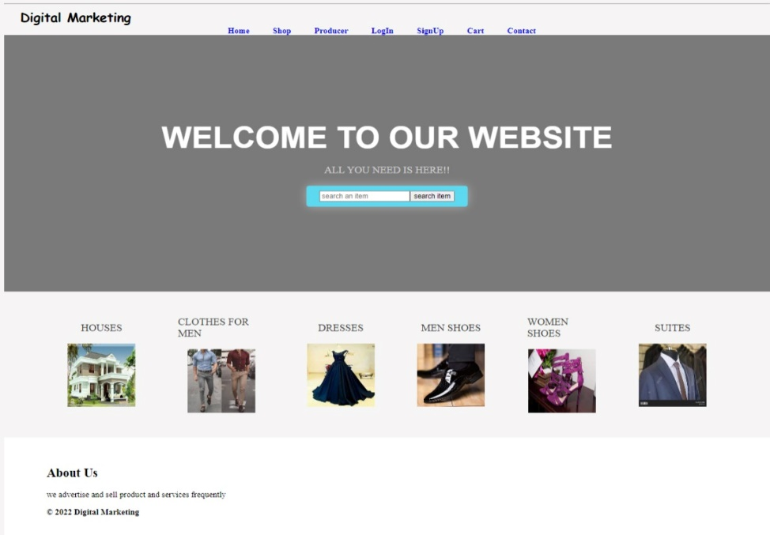

## **Products page**

This page is designed to present our products and services in details with their prices and the background information about them. Here, you are to add as many products as you wish depending to the consumers’ choices by clicking on “add to cart “button then after, selected will be arranged in the shopping cart page with total prices of selected items.

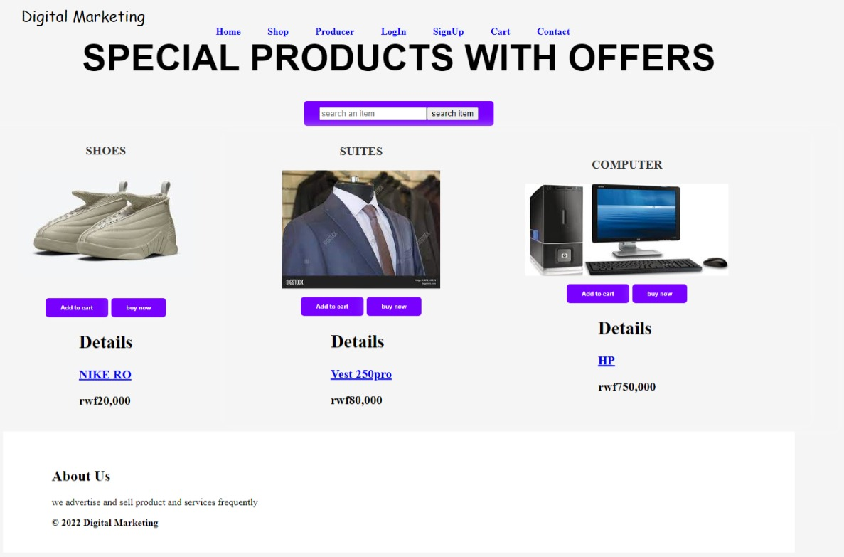

## **Producer page**

This, is designed to allow our stakeholders such as manufacturers and retailers of the products to add the items with their corresponding details such as product name, price, and category in their digital marketing accounts, so as being able to be advertised in the products page.

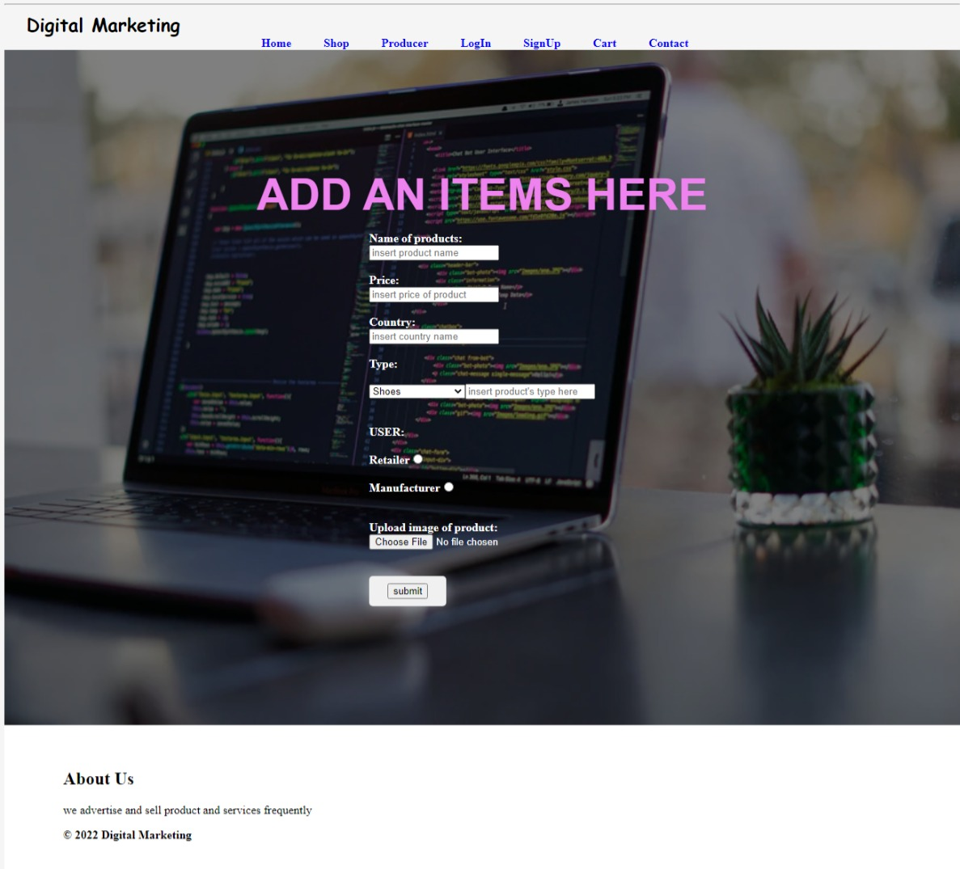

## **Signup page**

The new users (producers) are required to provide information so that being allowed to get access of login page requirements and being able to provide their products to our platforms.

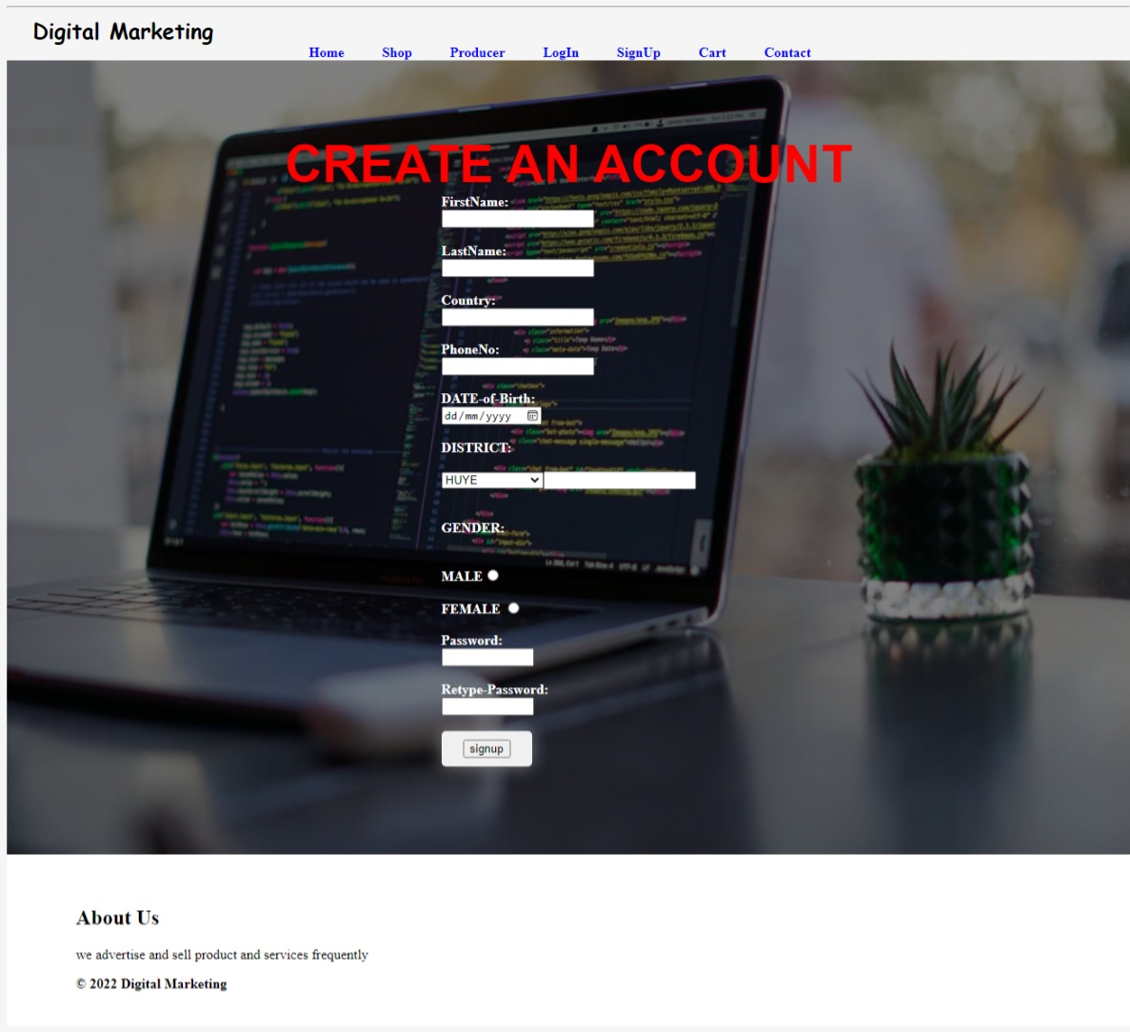

## **Login page**

After registration, a new user is now able to login in our platforms in order to provide their products and services in the producers. The users are required to fill all input type and then, system check if the provided informations are registered in the database; When the users’ data found, they will be able to proceed to next page so as to provide the products otherwise, the error message will be availed.

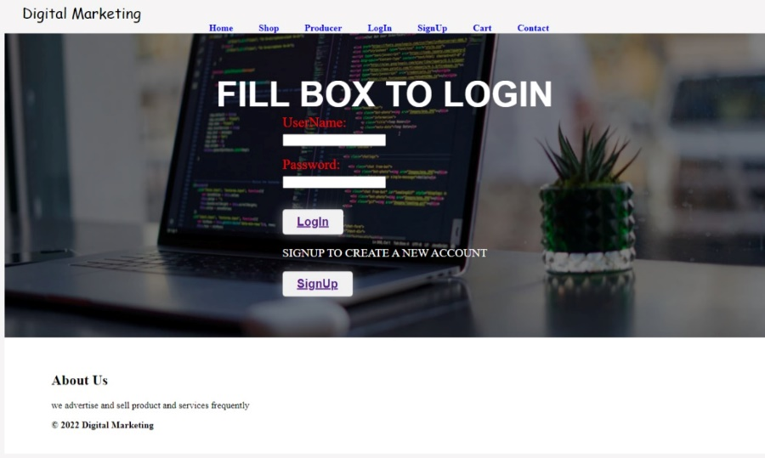

## **Contact page**

This page is designed for the customers’ ideas, comments, reputation, and advices. At this point, it will help us and our stakeholders to make creativity and innovation corresponding to the customers’ wishes. Therefore, communications will lead to the efficient provision of services and products with high quality.

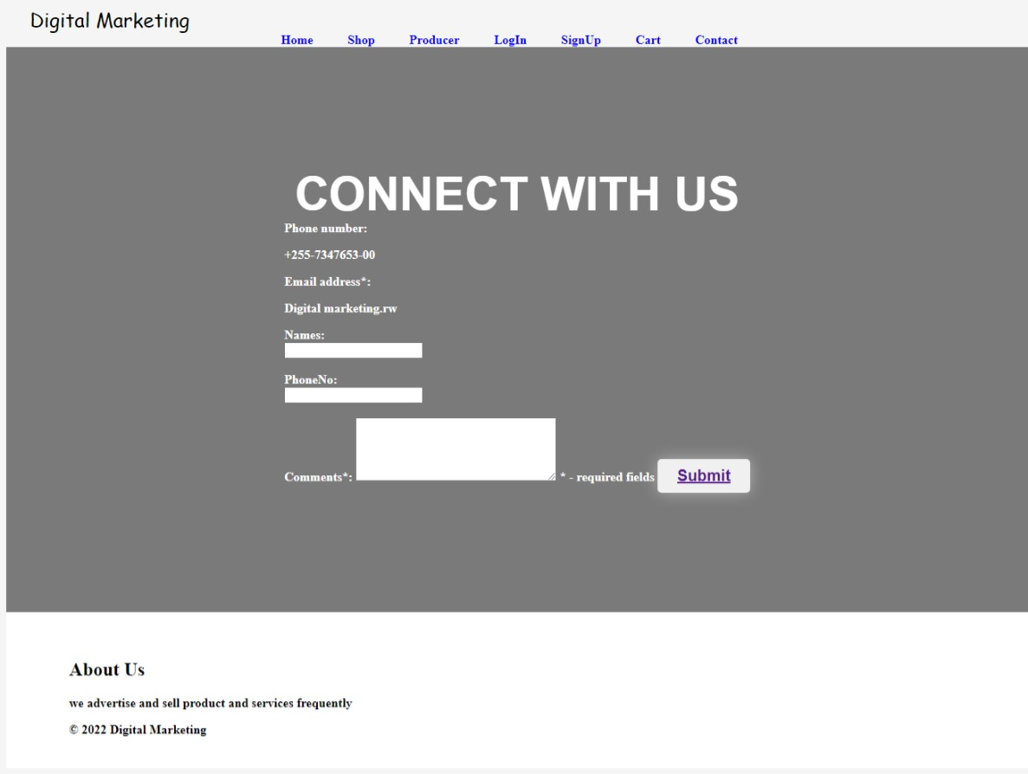

## **Database screenshots:**

1. **Sign Up table**

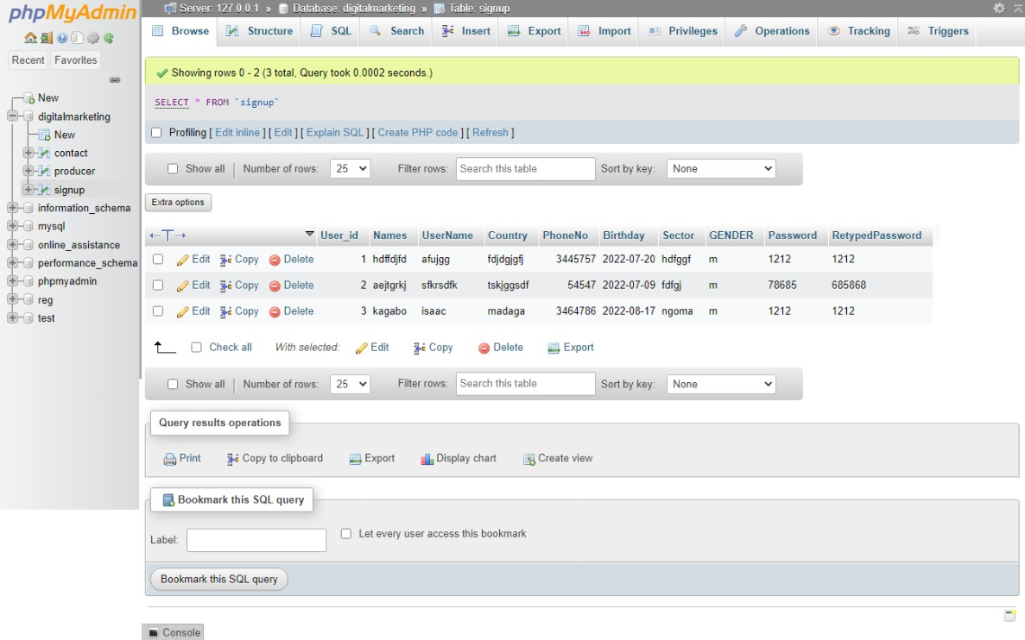

1. **Producer table**

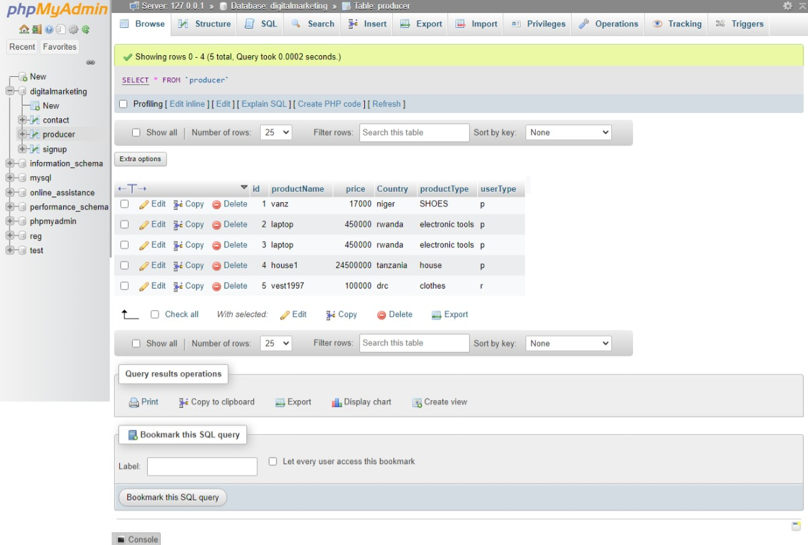

1. **Contact table**

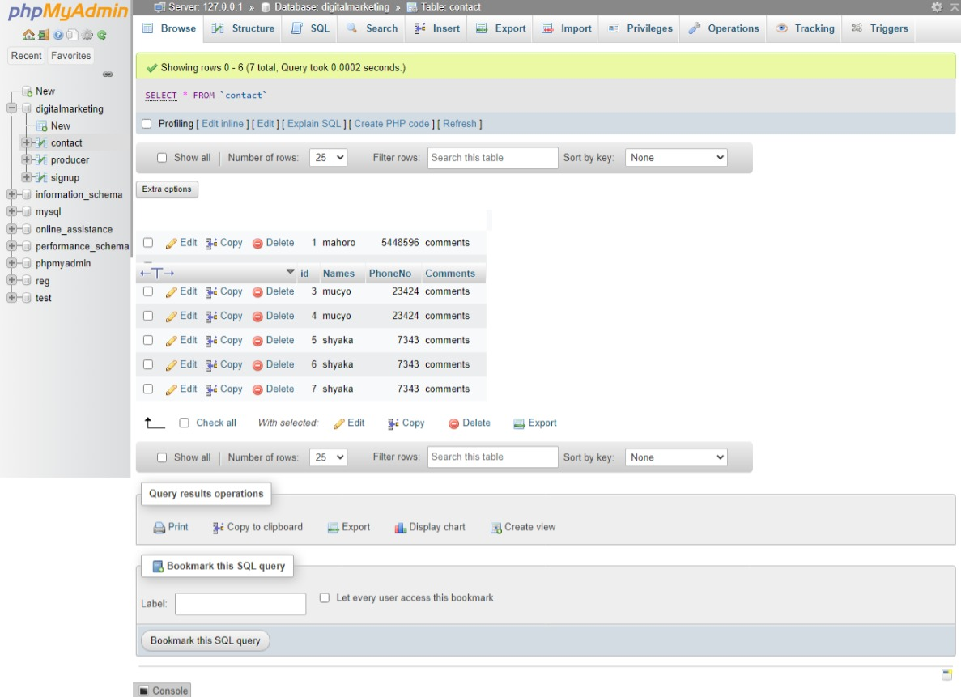

# **Conclusion**

By the conclusion, the project will be dynamically updated depending to changes in the world’s economy in order to fight against the problem that would occur in future related to marketing, promotion, production so as to provide high quality services; This will promote to the increased: digital innovations, creativity among producers which will overcome the problem of shortages of commodities and also increases the consumers’ choices. It will also promote globalization since products are produced from different countries around the world, which leads to the increased exports (increases the national GDP) and promotes to public relations that reduces the presence of wars hence favorable standard of living among people.

I tried to design this project in order to get satisfied with its expectations for what is supposed to overcome. The design and development is still in process at percentage of 40% related to what it could solve but the modification will be dynamically conducted.

# **6. Recommendation**

1. **Other students**

Firstly, I recommend other students for their support in terms of ideas, commitment, financial, and other promotions be the partner of this project so as create responsive world.

Students has different careers that will promote to development. Since there rapid increase in the use internet and technology among youth and elder generation, they should invest in the fields related to digital marketing in order to overcome the problems described in the above context.

**2. Department**

Department management office should introduce as many facilities and requirement needed as possible to those who are willing and able to design and develop the project that could handle the problems like the stated above and those which are currently facing the society and make challenges and limitations whose their presence leads to the discouraged development among themselves.

**3. Beneficiaries**

Consumers are recommended to provide as many ideas and supports as possible aimed to ensure proper and efficient provision of services by producers in terms of quality, assurance, and delivery of products provided.

On the side of producers, they should relate to the customers’ expectation from them and prepare modification in order to create the responsive market. This will increase the competition among themselves will also leads to the increased provision of high-quality products with low prices hence increased standards of living among people around the world.

# 7. Appendix

Here is the information related to the GitHub platforms

**-link:** <https://github.com/shyirambere221012822>

**-username:** shyirambere221012822

-**password:** shema221012822